Competition section "Dancing and dancing"

About various data formats

We will inform you about the format of various data sent to and received from the competition server. The data sent to the competition server has agent behavior information, and the data obtained from the competition server has field information. These are all JSON format data, and the details of each are as follows.

**Field information**

* time: integer (time for strategy step)
* turnLimit: integer (number of turn)
* width: integer (field width)
* height: integer (field height)
* points: integer 2D array (number of points in each cell)
* startedAtUnixTime: integer (Unix time when the game started)
* turn: integer (turn)
* tiled: integer 2D array (Tile placement status)
* teams: Object array (each team status)
  + teamID: integer (team ID)
  + agents: Object array, (each agent status)
  + agentID: integer (Agent ID)
  + x: integer (x coordinate)
  + y: integer (y coordinate)
  + tilePoint: integer (Tile point = олбог оноо)
  + areaPoint: integer (area point = талбайн оноо)
* actions: Object array (each action history)
  + agentID: integer (Agent ID)
  + type: string (Type of action, “move”: Move, “remove”: Remove, “stay”: Stop)
  + Dx: integer (x direction of action, -1: left, 0: middle, 1: right)
  + Dy: integer (direction of action in the y direction, -1: up, 0: middle, 1: down)
  + Turn: integer
  + Apply: integer (action adaptation status, -1: invalid, 0: conflict, 1: valid)

The field information points and tiled are two-dimensional arrays, and are described for each row in order from the upper left of the field. tiles is represented by the team ID of the team that placed the tile, and squares where no tile is placed are represented by 0.

**Agent behavior information**

・ Actions: Object array (actions of each agent)

・ AgentID: integer (Agent ID)

・ Type: string (type of action, “move”: movement, “remove”: removal, “stay”: stop)

・ Dx: integer (x direction of action, -1: left, 0: middle, 1: right)

・ Dy: integer (direction of action in the y direction, -1: up, 0: middle, 1: down)

Agent action information distinguishes agents by id, and specifies the type of action by type. Specify “move” to move, “remove” to remove tiles, and “stay” to stop. Everything else is invalid. The direction of action is a dx and dy pair. If dx is -1, left, 0 means medium, 1 means right, dy is -1, up, 0 is medium, and 1 is down.

The initial field information of the competition field in Fig. 1 will be like the "Field_information_turn0.json" file. When each team specifies the following actions in turn 1, the field status is as shown in Fig. 2, and field information such as the "Field_information_turn1.json" file is obtained.

In this sample, the team ID of the blue team is 5, the agent IDs of the two agents are 9,10, the team ID of the red team is 6, and the agent ID is 11,12. The team ID and agent ID used in the match will be provided at the participant liaison meeting on the day of the match.

|  |  |
| --- | --- |
| {  "actions": [  {  "agentID": 9,  "type": "move",  "dx": 1,  "dy": 1,  "turn": 1  },  {  "agentID": 10,  "type": "move",  "dx": -1,  "dy": -1  }  ]  } | {  "actions": [  {  "agentID": 11,  "type": "move",  "dx": 1,  "dy": 0,  "turn": 1  },  {  "agentID": 12,  "type": "move",  "dx": 0,  "dy": -1  }  ]  } |

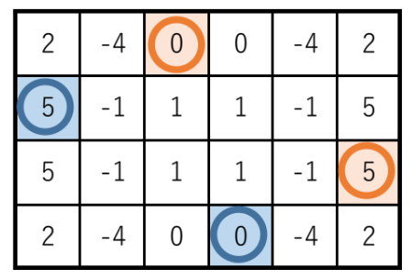

Figure 1: Example of a competition field

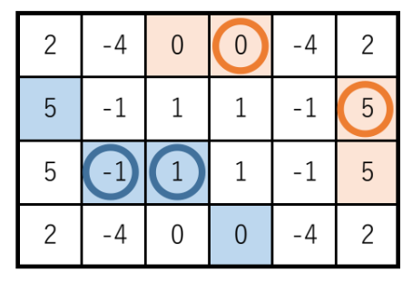

Figure 2: Field situation after turn 1